Bettie’s List
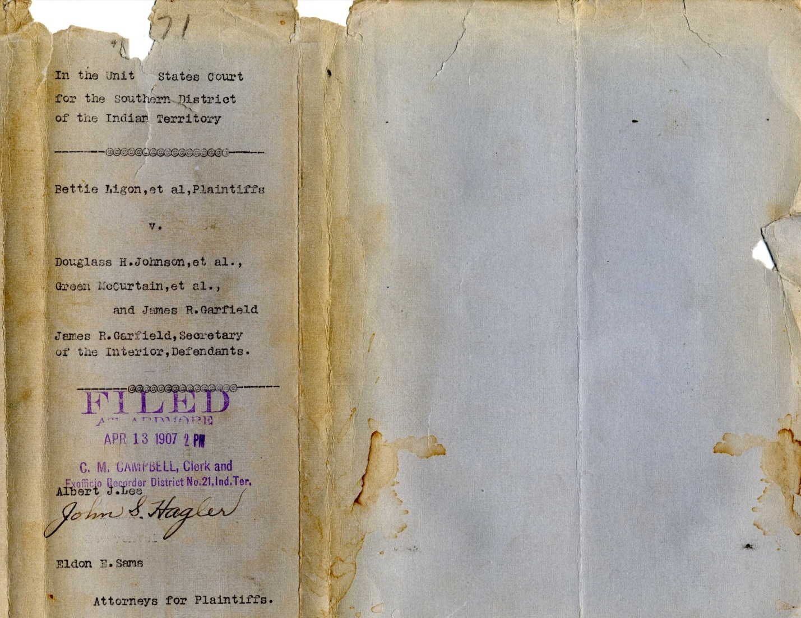
Equity Case 7071
Published and Edited by Terry LIGON

The purpose of this publication is to present the various documents that are part of the historical record that was generated in the effort of approximately two-thousand people seeking their rights as Chickasaw and Choctaw Indians. Their story appears in the United States Congressional Record, the United States Supreme Court and it was told in newspapers across the country as “The most important suit that was ever filed with the clerk of the United States district court since the establishment of the citizens tribunal is that of Bettie Ligon on behalf of herself and over 1,600 other freedmen of the Choctaw and Chickasaw nations.” This lawsuit involved property estimated value between $15,000,000-$20,000,000.

After many years of researching Equity Case 7071 I have come to the conclusion there may have been some kernel of truth to the story my father told me about his “Indian Grandmother, because this lawsuit was not only trying to rightfully have people transferred from the Chickasaw and Choctaw Freedmen Rolls to the Chickasaw and Choctaw Citizen by Blood roll; the story of his grandmother was about putting her life on the line so more than 1500 people could receive their rights as citizens as well as three hundred and twenty acres of land.

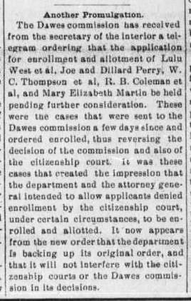
When the newspapers throughout Indian Territory proclaimed the “Bettie Ligon case” as one of the most significant cases in Indian Territory the story my father told me about his grandmother standing in the doorway of Carter County Courthouse to prevent the closing of the building doorway so the “people out in the country” could come to town and sign up for their land. His story about his Indian Grandmother that I doubted initially, now rings with so much truth more than one-hundred years later.

The people who appear on the following pages comprise what I like to call Bettie’s List and they have one of the most unique stories of Indian Territory. Their history has for the most part gone unnoticed by historians and has not been a subject for scholars but it is one that must be told. The men, women and children who make up Equity Case 7071 deserve recognition and I’m of the belief it will only come from their descendants as they begin to research and tell the story of their individual family that will add to the collective story of everyone on Bettie’s List.
1 Tahlequah Arrow april 29, 1905-p1, c4

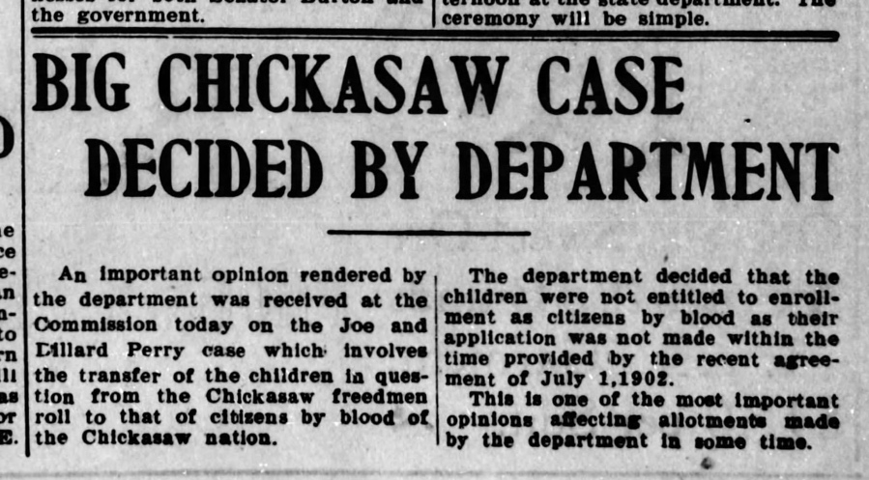
2 muskogee Times november 25, 1905 page 1, columns 5&6
The Joe and Dillard Perry brothers petition to transfer from the Chickasaw Freedmen Roll to the Chickasaw by Blood roll was considered to be the “test case” for the hundreds of similar cases were the child of a “recognized citizen” in the Chickasaw or Choctaw Nation was entitled to citizenship on the blood roll based on their lineal descent according to the Treaty of 1830 Dancing Rabbit Creek.

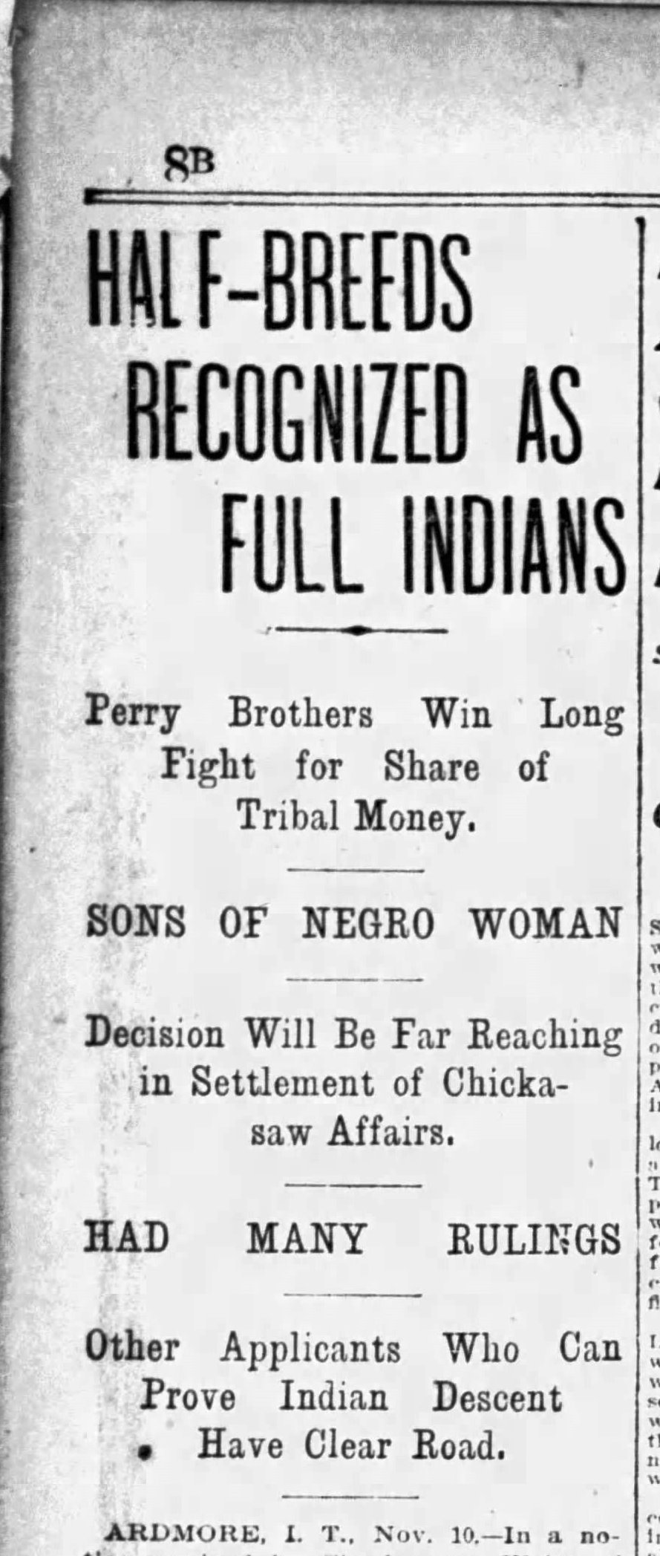
3 St. Louis post dispatch november 11, 1906, p2c1
In November of 1906, the courts ruled in favor of the Perry brothers and their claim to be entitled to a transfer from the Chickasaw Freedmen Roll to the roll of Chickasaw by Blood citizens. There had been considerable objection, obstruction and adverse court rulings with many politicians from the territories, tribes and other states objecting to acknowledging the children of women of African descent as “Indians” and entitled to the three-hundred and twenty acres of land that was to be allotted them as a citizen by blood.
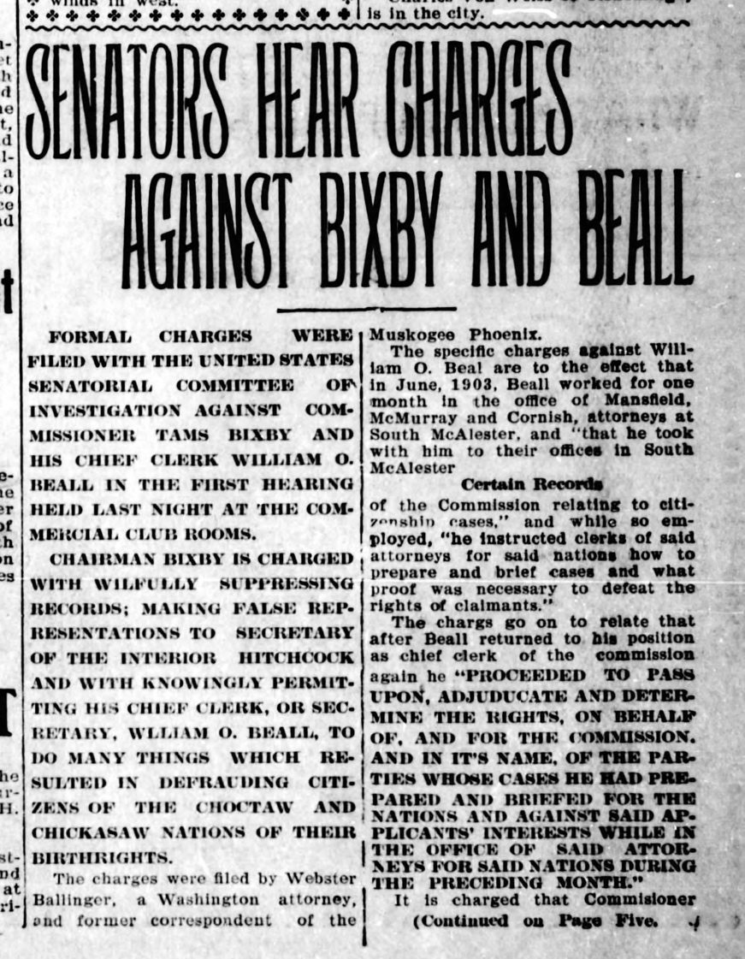
4 Muskogee Times Democrat-November 16, p1, c5&6
There were many attempts by the attorneys for the claimants of Equity Case 7071 to have their case settle through the process set up with the Dawes Commission but it was argued by their attorneys that officials within the Commission and Department of the Interior were suppressing and falsifying information that was to be given the Secretary of the Interior for the “fair hearing” on their claims as “lineal descendants” of a “recognized citizen” of the Chickasaw or Choctaw Nation.

There were at investigations into the allegations by Congress that discovered Chief Clerk William O. Beall while furloughed from his duties with the Commission took employment with the law firm that represented the Chickasaw and Choctaw Nation, clearly a “conflict of interest” which was condoned by Tams Bixby. Later both men would leave their positions with the Commission but for many of the petitioners seeking citizenship on the blood roll, the damage had been done and their pursuit of “equity” would continue.

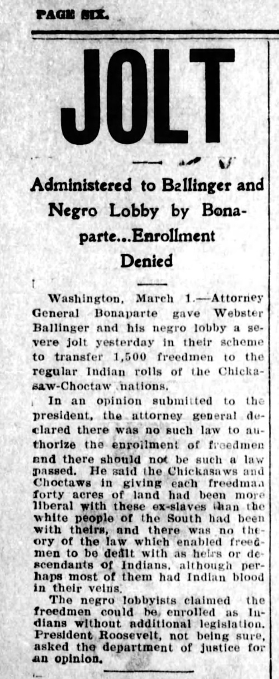
5 Muskogee Times democrat March 01, 1907-p6c1
Without regard to the various treaties and laws that addressed issues of “lineal descent” the United States Attorney General submitted his opinion that there were no laws that “authorize the enrollment of freedmen and there should not be such a law passed” to President Theodore Roosevelt.

Incredibly, Attorney General Bonaparte all but admitted the people petitioning to be transferred to the blood roll of citizens “perhaps most of them had Indian blood in their veins,” he held the Southern attitude “there was no theory of the law which enabled freedmen to be dealt with as heirs or descendants of Indian.”

His attitude was in the majority and would be the same attitude displayed once Indian and Oklahoma Territories became the state of Oklahoma when practically the entire Congressional delegation fought tooth and nail to prevent the rightful allotment of three-hundred and twenty acres that came with being transferred to the Chickasaw or Choctaw by Blood Roll.

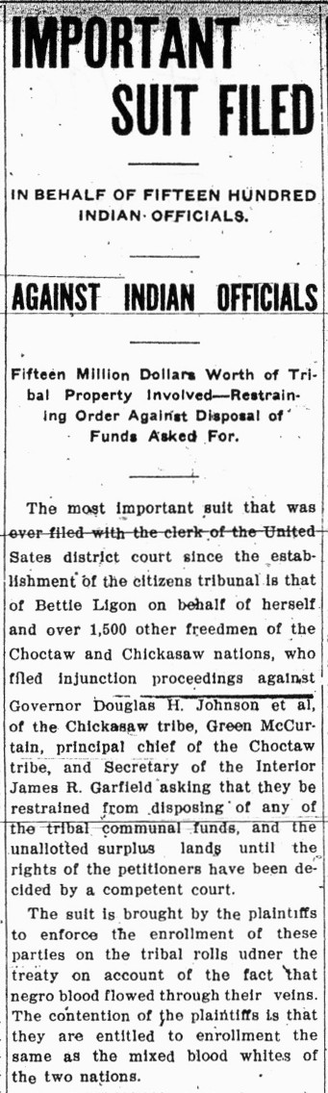
6 daily ardmoreite april 14, 1907 page 6 column 5&6
On April 13, 1907 undeterred with Bettie Ligon as the lead litigant attorneys from the law firm of Hagler, Lee and Ballinger filed “the most important suit that was ever filed with the clerk of the United States district court…”

Thus, the descendants of Bettie Ligon et al., v Douglass H. Johnson, et al., Green McCurtain, et al., and James R. Garfield, Secretary of the Interior, Defendants. Equity Case 7071 has survived for the descendants of these approximate two-thousand souls to finally have their due process and “Equality Under Law.”

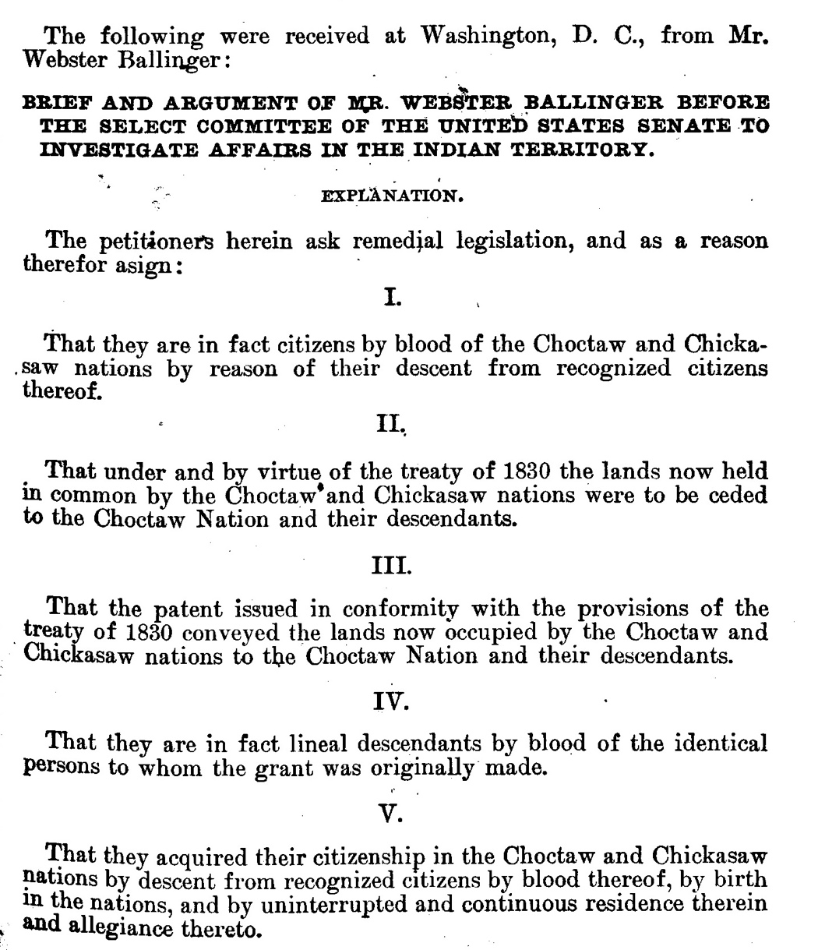
7 Senate report 5013, 59th Congress, 2nd session part 2, p1497

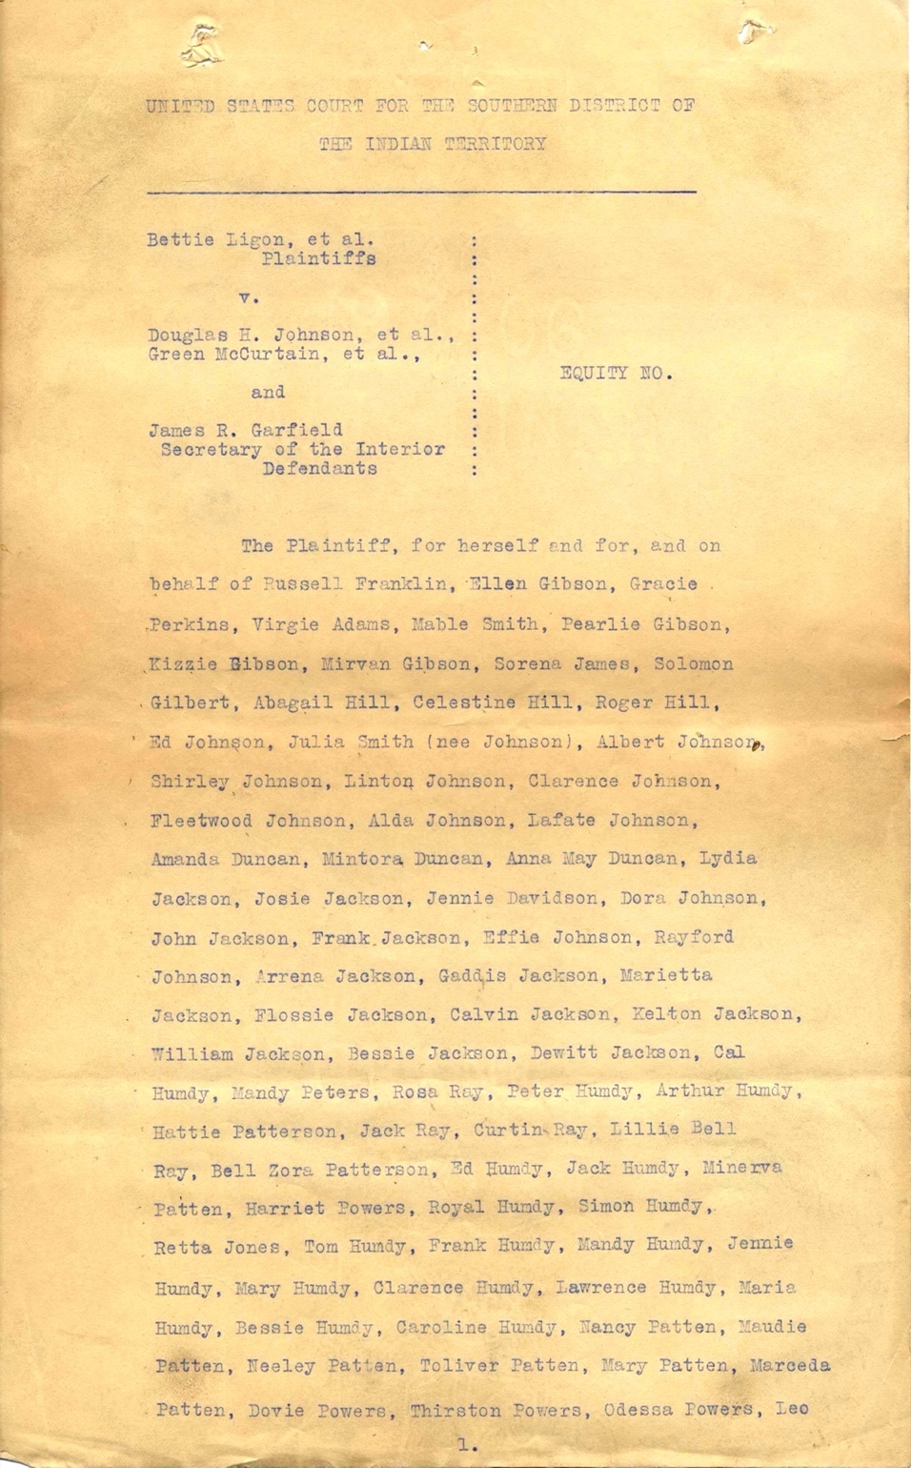
8 Original brief Equity case 7071 page 1

